INTRODUCTION

The production system is the collection of people, equipment and procedures organized to accomplish the manufacturing operations of a company.

The facilities in the production system are the factory, production machines and tooling, material handling equipment and the computer systems that control the manufacturing operations.

The product quantities produced in the factory can be divided into three ranges:

- Low production: quantities in the range of 1 to 100 units per year.
- Medium production: quantities in the range of 100 to 10000 units annually.
- High production: quantities over 100000 to millions of units annually.

Automation is the technology by which a process or procedure is accomplished without human assistance. It is implemented using a program of instructions combined with a control system that executes the instructions.

Basic elements of automated system
- Power to accomplish the process and operate the system.
- A program of instructions to direct the process.
- A control system to actuate the instructions.

Material handling is defined as the movement. Storage, protection, and control of materials throughout the manufacturing and distribution process including their consumption & disposal. The handling of the material must be done at the low cost in a timely manner, accurately, effectively & safely.

Fundamentals of automated assembly lines

An automated assembly system performs a sequence of automated assembly operations to combine multiple components into a single entity. The single entity can be final product or a sub assembly in a larger product. In many cases, the assembled entity consists of a base part to which other components are attached. The components are joined one at a time, so the assembly is completed progressively.

A selector is a device that acts a part filter, permitting only parts in the correct orientation to pass through. In correctly oriented parts are rejected back into the hopper.

An orientation is a device that allows the correctly oriented part to pass through, but orients the parts that were not oriented correctly first.

These selectors and can be used either on single cell machine or to a group of machines.

While being used on a group of machines that system is called as FMS (Flexible Manufacturing System).

DEFINING THE PROBLEM

Consider the problems like: -

- Material handling
- correct selection of the part
- maintaining the correct orientation of the part
- transferring the part from one location to another
- online inspection of the part

These problem appears different but are closely related to each other by the very fact that all these problems can be solved by a proper system that can detect a part and can decide upon the next step required to take with the part.

The material handling & the parts transfer requires the material to be handled (like) on a conveyer belt.

The inspection requires whether the part to be further processed or to be rejected.

The problem taken up in this project is partly inspection and partly pick & place from one place to other.

Consider a conveyer belt, an oncoming part is to be processed further but first it is required that the part should meet a particular descriptive feature let’s say height, otherwise it will not be worked upon.

Or consider a problem of a common conveyer belt handling a number of various parts in a plant, now it is required to transfer a part with some features on one line and others on some other line.

The solution is a dedicated system that understands the incoming part and can take a decision whether to allow the part to be further processed or to reject the part and even if it considers the part to be transferred to some other line.

In the FMS system this system is readily required to quickly decide upon the action required on the incoming part.

POWER SUPPLY

In alternating current the electron flow is alternate, i.e. the electron flow increases to maximum in one direction, decreases back to zero. It then increases in the other direction and then decreases to zero again. Direct current flows in one direction only.

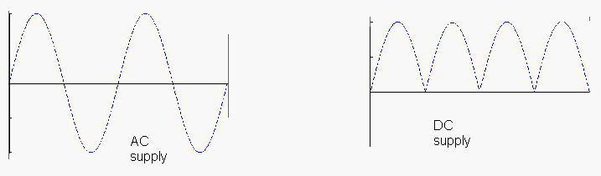

The requirements of low voltage D.C. (3V, 6V, 12V or 24V D.C) power for electronic circuits can be easily generated from the house hold A.C. supply by using a step down ----- transformer ----- & the A.C. can be converted to D.C. by using a ----- rectifier ----- circuit.

To eliminate the use of costly batteries; simple circuit is fabricated with the help of the diodes to solve the problem of power supply.

In general, at the input of the power supply, there is a power transformer. It is followed by a diode circuit called Rectifier. The output of the rectifier goes to a smoothing filter, and then to a voltage regulator circuit. The rectifier circuit is the heart of a power supply.

Hence requirements: -

- Power supply 220V A.C. 50 Hz
- Step down transformer
- Rectifier circuits (to convert to D.C.
- The filter circuit to smooth out the fluctuations in the D.C.
- The voltage regulator

TRANSFORMER

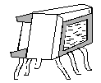
Principle of the transformer:-

Two coils are wound over a Core such that they are magnetically coupled. The two coils are known as the primary and secondary windings.

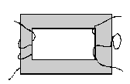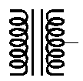

In a Transformer, an iron core is used. The coupling between the coils is source of making a path for the magnetic flux to link both the coils. A core as in fig.2 is used and the coils are wound on the limbs of the core. Because of high permeability of iron, the flux path for the flux is only in the iron and hence the flux links both windings. In the high frequency transformers, ferrite core is used. The transformers may be step-up, step-down, frequency matching, sound output, amplifier driver etc. The basic principles of all the transformers are same.
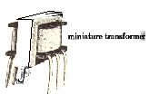
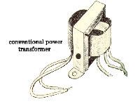

MINIATURE TRANSFORMER

RECTIFIER

Rectifier converts alternating current to flow in one direction only. When the anode of the diode is positive with respect to its cathode, it is forward biased, allowing current to flow but when its anode is negative with respect to the cathode, it is reverse biased and does not allow current to flow. This unidirectional property of the diode is useful for rectification.

A single diode arranged back-to-back might allow the electrons to flow during positive half cycles only and suppress the negative half cycles. Double diodes arranged back-to-back might act as full wave rectifiers as they may allow the electron flow during both positive and negative half cycles. Four diodes can be arranged to make a full wave bridge rectifier.

Different types of filter circuits are used to smooth out the pulsations in amplitude of the output voltage from a rectifier. The property of capacitor to oppose any change in the voltage applied across them by storing energy in the electric field of the capacitor and of inductors to oppose any change in the current flowing through them by storing energy in the magnetic field of coil may be utilized. To remove pulsation of the direct current obtained from the rectifier, different types of combination of capacitor, inductors and resistors may be also be used to increase to action of filtering.

Rectification

Rectification is a process of rendering an alternating current or voltage into a unidirectional one. The component used for rectification is called ‘Rectifier’. A rectifier permits current to flow only during the positive half cycles of the applied AC voltage by eliminating the negative half cycles or alternations of the applied AC voltage. Thus pulsating DC is obtained. To obtain smooth DC power, additional filter circuits are required.

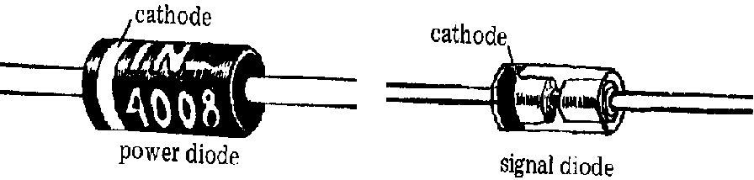

A diode can be used as rectifier. There are various types of diodes. But, semiconductor diodes are very popularly used as rectifiers. A semiconductor diode is a solid-state device consisting of two elements one being an electron emitter or cathode, the other an electron collector or anode. Since electrons in a semiconductor diode can flow in one direction only-from emitter to collector- the diode provides the unilateral conduction necessary for rectification. Out of the semiconductor diodes, copper oxide and selenium rectifier are also commonly used.

FULL WAVE RECTIFIER

It is possible to rectify both alternations of the input voltage by using two diodes in the circuit arrangement.

There is conduction by either of the diodes during the entire input-voltage cycle.

Though the full wave rectifier fills in the conduction gaps, it delivers less than half the peak output voltage that results from half-wave rectification.
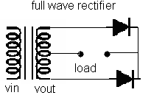

Since the two diodes have a common-cathode load resistor RL, the output voltage across RL will result from the alternate conduction of the diodes D1 and D2. The output waveform vout across RL therefore will be continuous.

BRIDGE RECTIFIER

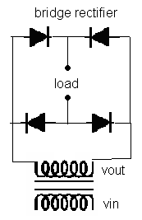
A more widely used full-wave rectifier circuit is the bridge rectifier. It requires four diodes instead of two, but avoids the need for a centre-tapped transformer. During the positive half-cycle of the secondary voltage, diodes D2 and D4 are conducting and diodes D1 and D3 are non-conducting. Therefore, current flows through the secondary winding, diode D2, load resistor RL and diode D4. During negative half-cycles of the secondary voltage, diodes D1 and D3 conduct, and the diodes D2 and D4 do not conduct. The current therefore flows through the secondary winding, diode D1, load resistor RL and diode D3. In both cases, the current passes through the load resistor in the same direction. Therefore, a fluctuating, unidirectional voltage is developed across the load.

Filtration

The rectifier circuits we have discussed above deliver an output voltage that always has the same polarity: but however, this output is not suitable as DC power supply for solid-state circuits. This is due to the pulsation or ripples of the output voltage. This should be removed out before the output voltage can be supplied to any circuit. This smoothing is done by incorporating filter networks.

The filter network consists of inductors and capacitors. The inductors oppose any change in the magnitude of a current flowing through them by storing up energy in a magnetic field. An inductor offers very low resistance for DC whereas; it offers very high resistance to AC. Thus, a series connected choke coil in a rectifier circuit helps to reduce the pulsations or ripples to a great extent in the output voltage. The filter capacitors are usually connected in parallel with the rectifier output and the load. AC can pass through a capacitor but DC cannot, the ripples are thus limited and the output becomes smoothed. When the voltage across its plates tends to rise, it stores up energy back into voltage and current. Thus, the fluctuations in the output voltage are reduced considerable. Filter network circuits may be of two types in general:

CHOKE INPUT FILTER

If a choke coil or an inductor is used as the ‘first- components’ in the filter network, the filter is called ‘choke input filter’. The D.C. along with AC pulsation from the rectifier circuit at first passes through the choke (L). It opposes the AC pulsations but allows the DC to pass through it freely. Thus AC pulsations are largely reduced. The further ripples are by passed through the parallel capacitor C. But, however, a little ripple remains unaffected, which are considered negligible. This little ripple may be reduced by incorporating a series a choke input filters.

CAPACITOR INPUT FILTER

If a capacitor is placed before the inductors of a choke-input filter network, the filter is called capacitor input filter. The D.C. along with AC ripples from the rectifier circuit starts charging the capacitor C. to about peak value. The AC ripples are then diminished slightly. Now the capacitor C, discharges through the inductor or choke coil, which opposes the AC ripples, except the DC. The second capacitor C by passes the further AC ripples. A small ripple is still present in the output of DC, which may be reduced by adding additional filter network in series.

CIRCUIT DIAGRAM

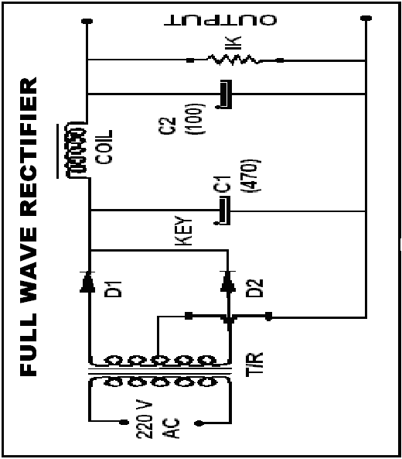

Run conveyer belt
Is material detected?
Stop the conveyer belt
Run gripper motor cw.
Call delay
Stop gripper motor
Run arm motor cw.
Call delay
START
Stop arm motor
Run gripper motor ccw.
Stop gripper motor
Call delay
Run arm motor ccw.
Is arm at origin?
Stop arm motor
1
1
Yes

No
No
Yes
Yes
2
2
ROBOTICS:

A mechanical device that sometimes resembles a human and is capable of performing a variety of often complex human tasks on command or by being programmed in advance is defined as a robot

A Robot never becomes fulfill until it can take decisions. We can’t go for computers for the computation & intelligence. But we can use single chip microcontrollers for controlling only predefined tasks. The robot’s full control is embedded into one chip which is otherwise known as embedded systems designing.

Embedded System Through 8051.

In this project we show that how we convert simple robotic arm into a fully automatic robotic arm. After putting a automation logic it is very useful for industrial automation.
In this project we use many step to control automation system.

- CONVEYER BELT SYSTEM.

- INFRA RED SENSOR INTERRUPTION LOGIC.

- AUTO GRIPPER SYSTEM

AUTO MOVE ROBOTIC ARM..

CONVEYER BELT SYSTEM.

In this project we use slow speed dc gear motor to run the conveyer belt. Start signal is provided by the microcontroller circuit. In the main unit when the supply unit is on, then conveyer belt is not start automatically. Start switch of the conveyer belt is provided by the microcontroller.

First work of the microcontroller is to start the conveyer belt after pressing a switch and then to monitor the infra red sensor for reflection.

After conveyer belt starts then our infra red sensor monitors the oncoming object. If the object is suitable for the machine then object moves on the belt but if the object is above height then infra red sensor sense the signal with the help of reflection from the object. When infra red sensor reflect the rays then machine sense the signal through photodiode. Photodiode and infra red sensor connected as pair on a certain height and detects the reflected signal.

Now conveyer is stopped automatically and gripper connected above the sensor is activated to grip the object. For the gripper we use second dc gear motor. Control signal to grip the object is provided by the microcontroller itself.
After gripping the object third motor starts and move the robotic hand to other side, after some delay third motor is stop and now gripper opens itself and releases the object in the basket. After releasing the object, third motor again starts & moves the robotic hand to reverse side with the same delay and start the conveyer belt automatically

MAIN part of this project is microcontroller that provides a signal to the robotic arm to start the conveyer belt then sense the reflection, if reflection is there then stop the conveyer belt, and after stopping the conveyer belt grip the gripper, move the robotic hand, drop the object in basket and again move the conveyer belt. This entire signal is provide by the microcontroller.

We wrote a program for this IC. Program is to be written in the ASM codes and then this code is converted into hex code with the help of the assembler. In this project we use 8051 IDE software to assemble the ASM codes into HEX code. Once the code is converted into HEX code then we transfer this code in the blank IC with the help of program kit connected with the computer.

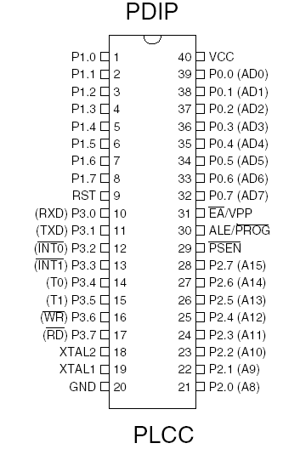

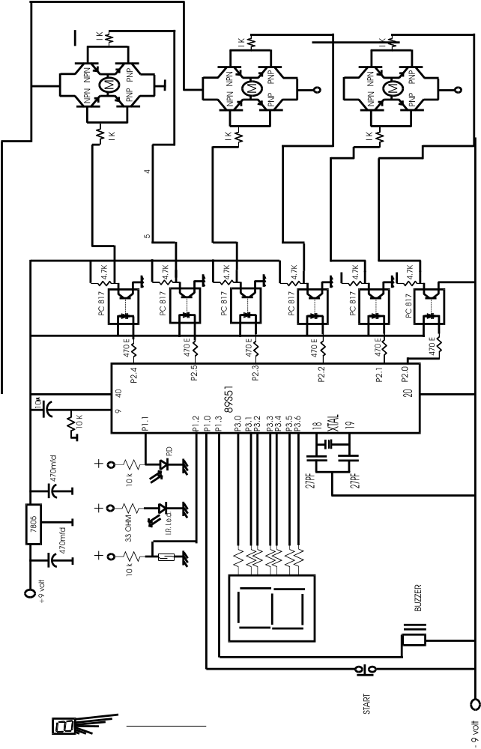

8051 micro controller

The 8051
The 8051 developed and launched in the early 80`s, is one of the most popular micro controller in use today. It has a reasonably large amount of built in ROM and RAM. In addition it has the ability to access external memory.
The generic term `8x51` is used to define the device. The value of x defining the kind of ROM, i.e. x=0, indicates none, x=3, indicates mask ROM, x=7, indicates EPROM and x=9 indicates EEPROM or Flash.
A note on ROM
The early 8051, namely the 8031 was designed without any ROM. This device could run only with external memory connected to it. Subsequent developments lead to the development of the PROM or the programmable ROM. This type had the disadvantage of being highly unreliable.
The next in line, was the EPROM or Erasable Programmable ROM. These devices used ultraviolet light erasable memory cells. Thus a program could be loaded, tested and erased using ultra violet rays. A new program could then be loaded again.
An improved EPROM was the EEPROM or the electrically erasable PROM. This does not require ultra violet rays, and memory can be cleared using circuits within the chip itself.
Finally there is the FLASH, which is an improvement over the EEPROM. While the terms EEPROM and flash are sometimes used interchangeably, the difference lies in the fact that flash erases the complete memory at one stroke, and not act on the individual cells. This results in reducing the time for erasure.

Different Microcontrollers In Market.

- INTEL These are the first to manufacture microcontrollers. These are not as sophisticated other microcontrollers but still the easiest one to learn. Intel 8051 is CISC architecture which is easy to program in assembly language and also has a good support for High level languages. The memory of the microcontroller can be extended up to 64k. The 8051 microcontroller is in the field for more than 20 years.

- Atmel Atmel’s AVR microcontrollers are one of the most powerful in the embedded industry. This is the only microcontroller having 1kb of ram even the entry stage. But it is unfortunate that in India we are unable to find this kind of microcontroller.

- PHILIP Philips‘s 8051 derivatives has more number of features than in any microcontroller. The costs of the Philips microcontrollers are higher than the Atmel’s

Architecture

Architecture is must to learn because before learning new machine it is necessary to learn the capabilities of the machine. This is some thing like before learning about the car you cannot become a good driver. The architecture of the 8051 is given below.

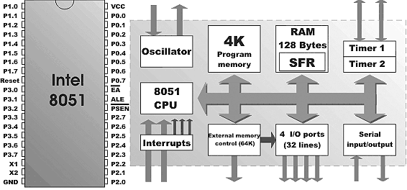

The 8051 doesn’t have any special feature than other microcontroller. The only feature is that it is easy to learn. Architecture makes us to know about the hardware features of the microcontroller. The features of the 8051 are

- 4K Bytes of Flash Memory
- 128 x 8-Bit Internal RAM
- Fully Static Operation: 1 MHz to 24 MHz
- 32 Programmable I/O Lines
- Two 16-Bit Timer/Counters
- Six Interrupt Sources (5 Vectored)
- Programmable Serial Channel
- Low Power Idle and Power Down Modes

Power supply:
8051 can handle power supply of 3.5 volts to 7 volts with no problem. Always use a Decoupling Capacitor between the Power supply and the Ground. Decoupling capacitors are used to avoid the spikes. Pin 40 is for VCC and Pin 20 is for Gnd.

Reset Circuitry:

As soon as you give the power supply the 8051 doesn’t start. You need to restart for the microcontroller to start. Restarting the microcontroller is nothing but giving a Logic 1 to the reset pin at least for the 2 clock pulses. So it is good to go for a small circuit which can provide the 2 clock pulses as soon as the microcontroller is powered.

This is not a big circuit we are just using a capacitor to charge the microcontroller and again discharging via resistor.

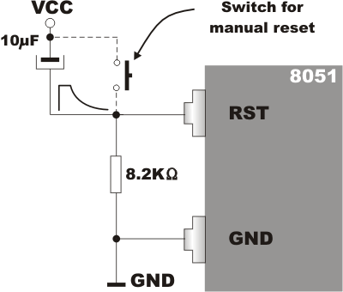
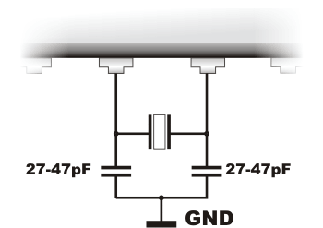
Crystals
Crystals provide the synchronization of the internal function and to the peripherals. Whenever ever we are using crystals we need to put the capacitor behind it to make it free from noises. It is good to go for a 33pf capacitor.

We can also resonators instead of costly crystal which are low cost and external capacitor can be avoided.

But the frequency of the resonators varies a lot. And it is strictly not advised when used for communications projects.

Let Us See The Architecture In Detail.

1. Ports 2. Timers 3. Interrupts

PORTS

Ports used to communicate with the outside world.

8051 is having 4 ports & each has 8 I/O Pins. Simplest I/O Port in all microcontroller.

Port0, Port2 can be used for the External Addressing. If our code has exceeded the 4kb then we need to use extra ROM & RAM. For addressing the extra memory chips we need to loose our Port 0 & port 2.

Port3 is one of the important ports; this has the serial port, timers and interrupts pins.

Port1 is free can be used only as Port!!

In this project we use three dc motor to run the conveyer belt and robotic arm. One motor to run the conveyer belt and second motor is for the gripper and third motor is for the hand movement,

Motors

To make the robots mobile we need to have motors and the control circuitry that could control the motors. There are different kinds of motors available for different application.

DC motor
Stepper motor
Servo motor

DC motors
These are the motors that are commonly found in the toys and the tape recorders. These motors change the direction of rotation by changing the polarity. Most chips can't pass enough current or voltage to spin a motor. Also, motors tend to be electrically noisy (spikes) and can slam power back into the control lines when the motor direction or speed is changed.
Specialized circuits (motor drivers) have been developed to supply motors with power and to isolate the other ICs from electrical problems. These circuits can be designed such that they can be completely separate boards, reusable from project to project.
In this project we use dc gear motor with the micro controller with special interface circuit. In the interface circuit we use optocoupler circuit. . For controlling three motor we are using total six controls. From the microcontroller we get a six output to control three motors. By using six controls we control the direction of three motor. We use six optocoupler to interface the three motor’s here in this project. Output of the six optocoupler is connected to the three h bridge circuit. H bridge circuit not only takes a power hold of this project but at the same time control the direction of the motor.
A very popular circuit for driving DC motors (ordinary or gearhead) is called an H-bridge. It's called that because it looks like the capital letter 'H' on classic schematics. The great ability of an H-bridge circuit is that the motor can be driven forward or backward at any speed, optionally using a completely independent power source.

The H-Bridge Circuit
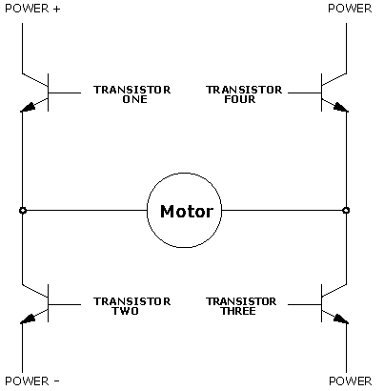

This circuit known as the H-bridge (named for its topological similarity to the letter "H") is commonly used to drive motors. In this circuit two of four transistors are selectively enabled to control current flow through a motor.
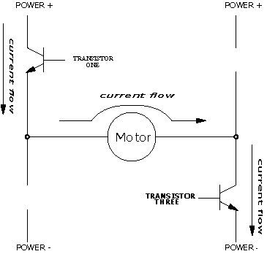

Opposite pair of transistors (Transistor One and Transistor Three) is enabled, allowing current to flow through the motor. The other pair is disabled, and can be thought of as out of the circuit.
By determining which pair of transistors is enabled, current can be made to flow in either of the two directions through the motor. Because permanent-magnet motors reverse their direction of turn when the current flow is reversed, this circuit allows bidirectional control of the motor.

The H-Bridge with Enable Circuitry
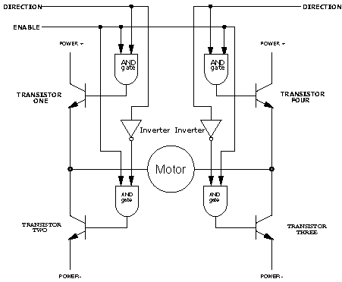

It should be clear that one would never want to enable Transistors One and Two or Transistors Three and Four simultaneously. This would cause current to flow from Power + to Power - through the transistors, and not the motors, at the maximum current-handling capacity of either the power supply or the transistors. This usually results in failure of the H-Bridge. To prevent the possibility of this failure, enable circuitry as depicted in Figure is typically used.

In this circuit, the internal inverters ensure that the vertical pairs of transistors are never enabled simultaneously. The Enable input determines whether or not the whole circuit is operational. If this input is false, then none of the transistors are enabled, and the motor is free to coast to a stop.

By turning on the Enable input and controlling the two Direction inputs, the motor can be made to turn in either direction.
Note that if both direction inputs are the same state (either true or false) and the circuit is enabled, both terminals will be brought to the same voltage (Power + or Power - , respectively). This operation will actively brake the motor, due to a property of motors known as back emf, in which a motor that is turning generates a voltage counter to its rotation. When both terminals of the motor are brought to the same electrical potential, the back emf causes resistance to the motor's rotation.

Stepper motors
Stepper motors are special kind of heavy duty motors having 2 or 4 coils. The motors will be stepping each time when it get the pulse. As there are many coils in the motors we need to energize the coils in a specific sequence for the rotation of the motor. These motors are mostly used in heavy machines. The figure shown below consists of a 4 coil stepper motor and the arrow mark will rotate when the coils are energized in the sequence.

Unlike DC motors stepper motors can be turned accurately for the given degrees.

Servo motors
Servo motors unlike the stepper motor it has to be controlled by the timing signal. This motor has only one coil. It is mostly used in robots for its lightweight and low power consumption. The servo motors can also be accurately rotated by the making the control signal of the servo motor high for a specific time period. Actually the servo motor will be having 3 wires where 2 are for power supply and another one is for the control signal. Driving the servomotors is so simple that you need to make the control signal high for the specific amount of time. The width of the pulse determines the output position of the shaft

Object Detection

﻿Detecting objects without whiskers doesn’t require anything as sophisticated as machine vision. Some robots use RADAR or SONAR (sometimes called SODAR when used in air instead of water). An even simpler system is to use infrared light to illuminate the robot’s path and determine when the light reflects off an object.The IR illuminators and detectors are readily available and inexpensive.

More about IR - Detector

The IR detectors have built-in optical filters that allow very little light except the 980 nm infrared that we want to detect onto its internal photodiode sensor. The infrared detector also has an electronic filter that only allows signals around 38.5 kHz to pass through. In other words, the detector is only looking for infrared that’s flashing on and off 38,500 times per second.

This prevents common IR interference sources such as sunlight and indoor lighting. Sunlight is DC interference (0 Hz), and indoor lighting tends to flash on and off at either 100 or 120 Hz, depending on the main power source in the region where you reside. Since 120 Hz is way outside the electronic filter’s 38.5 kHz band pass frequency, it is, for all practical purposes, completely ignored by the IR detectors.

As the receivers detects only modulated signals we need to have our IR LEDs modulated in 36 KHz to 40 KHz. We can use 555 timer to make this 40 KHz pulse. The simple circuit is given below.

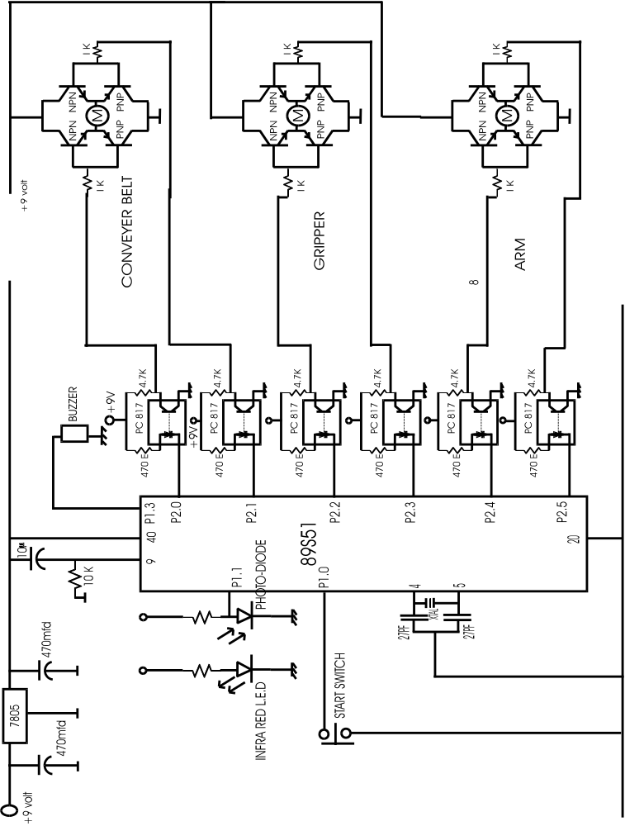

CIRCUIT WORKING:
Pin no 40 is connected to the positive supply. . 5 volt regulated power supply is provided to the pin no 40. Pin no 9 is connected to the reset pin. On this pin we connect one 10 mfd capacitor and 10 k ohm resistor. With the help of this capacitor and resistor we force the micro controller to start up from the 0000h location when start. Start switch is connected to the pin no p1.0. On this pin we use push to on switch. When we press this switch then pin no p1.0 become more negative and circuit start and conveyer belt is on move. Conveyer belt is start because p2.0 and p2.1 pins are give a pulse to the H bridge circuit to give a voltage to the dc motor. When dc motor is on then conveyer belt is on with the help of h bridge circuit.. now program is shifted to infra red sensor, if there is any obstruction against infra red led then infra red sensor sense the signal and at this time port p1.1 is more negative and circuit stop the conveyer belt. When conveyer belt is stop then second motor is switch on to grip the object. When object is gripped then third motor is on and move the object to the basket, third motor is connected to the p2.4 and p2.5. One buzzer is connected to the port p1.3, this buzzer is on when infra red sensor sense the signal . .

Control of motor is done by the H bridge circuit. In the H bridge circuit we use two npn transistor and two pnp transistor. With the help of this two npn transistor and two pnp transistor we control the direction of the motor.

H bridge is interface with the microcontroller with the hel p of opto-coupler circuit., Opto-coupler circuit not only interface the microcontroller with the H bridge but also provide a electrical isolation between microcontroller and dc motor circuit.

PROGRAM CODE OF THE MICROCONTROLLER.
org 0000h
ORG MEANS ORIGION, ON THIS POINT WE START THE PROGRAM CODE, WHEN MICROCONTROLLER IS ON THEN PROGRAM IS RESET AUTOMATICALLY AND START FROM THE 0000 LOCATION.
sjmp main

main:

jnb start,s1
sjmp main

s1:
clr p2.0 ; motor1 for conveyer belt
setb p2.1 ; motor1
jnb input,s2 ; input for the ir sensor
sjmp s1

s2:
setb p2.0 ; stop the motor
setb p2.1 ; stop the motor1( conveyer belt)

clr p1.3 ; buzzer on

acall delay1
setb p1.3 ; stop buzzer

clr p2.4 ; start motor3 forward
setb p2.5 ; start motor3 forward
acall delay2
setb p2.4
setb p2.5

setb p2.2 ; start motor 2 reverse
clr p2.3 ; start motor 2 reverse

acall delay1
setb p2.2
setb p2.3
setb p1.3 ; stop the alarm

D1: CLR p2.4
SETB p2.5
JB P1.2,D2
SJMP D1

acall delay2
D2: CLR p2.4
setb p2.5

ORIGINAL PROGRAM

MAIN: ORG 000H
SETB 80H ; RESET IR
SETB 84H ; RESET MAGNETIC SENSOR
SJMP STEP1

DELAY: MOV R5,#FFH
MOV R6,#22H
AGAIN: DJNZ R5,AGAIN
DJNZ R6,AGAIN
RET

STEP1: CLR 90H ; CONVEYER START
CLR 80H
JNB 80H,STEP2 ; IR DETECT
SJMP STEP1
STEP2: SETB 90H ; CONVEYER STOP
CLR 82H ; BUZZER ON
SETB 83H
ACALL DELAY
SETB 82H ; BUZZER OFF
CLR 92H ; M2 START FORWARD
SETB 93H
ACALL DELAY
SETB 92H ; M2 STOP
CLR 94H ; M3 START FORWARD
SETB 95H
ACALL DELAY
ACALL DELAY
SETB 94H ; M3 STOP
SETB 92H ; M2 START REVERSE
CLR 93H
ACALL DELAY
SETB 93H ; M2 STOP
STEP3: SETB 94H ; M3 START REVERSE
CLR 95H
;CLR 84H
JB 84H,STEP3 ; MAGNETIC SENSOR FOR ARM
SETB 95H ; M3 STOP
SJMP MAIN
END

BURNER FOR THE 8051 CHIP

BlowIT 2051 is simplest possible burner for AT89C2051 Flash Microcontroller. It is “as simple as possible” only designed for fast and dirty jobs, where you need to get going and fast. Only very few components are required. Functionality is minimal, only erase and program are implemented.

Power Supply

Basically +5 and +12 are available inside the PC on the floppy/HD power cable as example. Well use them at your own risk. A simple power supply can be buildt using 7812 and 7805.
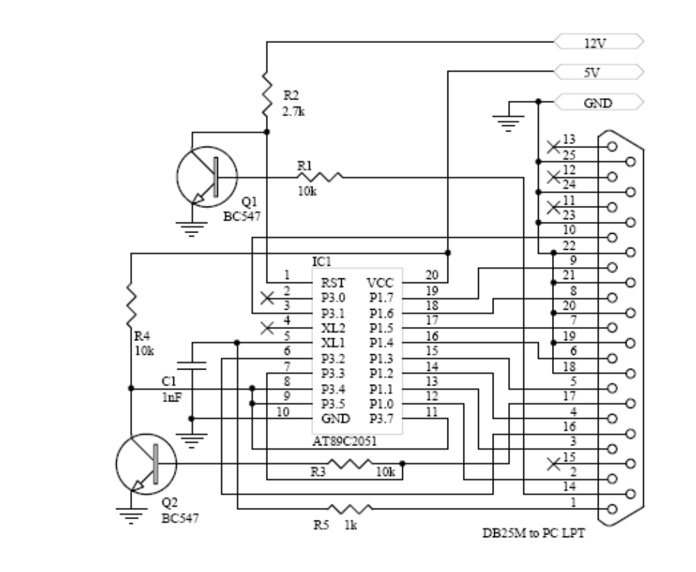 PROCEDURE

- At first the required wooden structure was given the shape

  - The wooden base structure 18”*12” was made out of plywood.
  - Than an ordinary wood piece carved to be as a robotic arm of about 6”.
  - A small table like structure was also created to accommodate the operation of the conveyer belt.
  - Another tabular structure was raised to accommodate the robotic arm and its drive motors.

- All the moving parts like the arm of the robot was created by fixing the D.C. geared motor at the one end of the arm (wooden rod) to actuate the gripper. The gripper is actuating in both fwd. rev. direction.

- The gripper was made out of the sheet metal and was connected to the end of the drive of the D.C geared motor, which was fixed to the robotic arm.

- The conveyer belt set up was put into place along with its drive motor.

- The robotic arm was than connected on its stand over a third D.C. geared motor to supply the whole rotation (fwd. as well as rev.) to the robotic arm along with its gripper as per requirement.

- The IR (including IR LED & a photo diode) detector was placed at a suitable distance on the conveyer belt.

- The magnetic reed switch was positioned to the home position of the robotic arm, such that the magnet that is placed on the robotic arm is as close to the reed switch as possible but sufficiently far away to actuate the reed switch when robotic arm is well over the conveyer belt.

- The circuit on the bead board was than prepared separately before actually assembling it to the rest of the hardware

- 12 n-p-n BJT’s were taken and were connected in a group of 4 each to create the H-bridge circuit to control the direction of the of the D.C. motor

- Then to isolate the H-bridge circuitry voltage to that of the D.C. motor operating voltage the opto-coupler were connected with the H-Bridge. A total of 6 opto-coupler were used (2 for each motor * 3).

- Then the seat of the 40 pin 8051 microcontroller was soldered to the bead board.

- With the pins XTAL1 & XTAL2 of the microcontroller a 12 MHz crystal (for timing the machine cycle as well as its delay loop) was also connected.

- A reset circuitry used to reset the microcontroller was connected to the reset pin of the microcontroller to set the logic 1 to the pins of microcontroller.

- To supply the power to the logic circuit, a step down center –tapped transformer with a full wave rectifier circuit including a filter circuit was used (to eliminate the A.C. pulse).

- The potential supplied by the step down transformer is around 9V; to control the limit of this voltage to 5V for the microcontroller to work fluctuation freely an electronic voltage regulator was used along with the full wave rectifier.

- Another transformer (step down) also with a proper rectification was connected to supply the power to the three D.C. motors.

(The power supplies the electronic circuit & that of the 3 D.C. motors are intentionally kept separate.)

- Meanwhile the H-bridge was connected to the requisite ports of the microcontroller & a buzzer was also connected as a warning source to remind the operation of the project.

- To protect the various circuit components like IR, H-bridge, and PORT0 (to be supplied with external pull down registers), suitable resisters were used.

- All the three motors, a buzzer, the reed switch & the IR detector was connected to the require port via H-bridges.

- On the Rigel’s microcontroller assembler program the program was written as per the proposed algorithm.

(The program was generated as the .asx file. The reason for such a file extension is that the assembler can recognize this file extension as is capable of generating the required .hex file to be fed to the microcontroller)

- The program was compiled & the generated hex file was burned to the 8051 microcontroller by using the BlowIT 8051 burner.

ROBOTIC ARM
CONVEYER BELT
GRIPPER
CONTROLLER
IR SENSOR
MAGNETIC REED SENSOR

